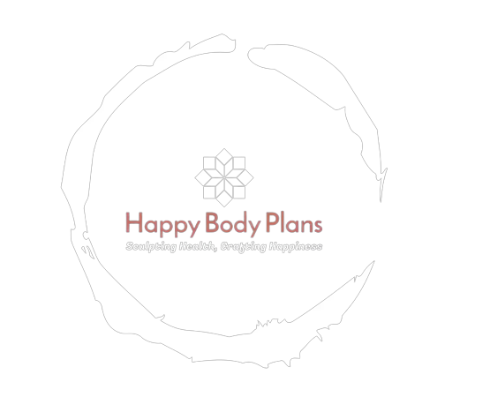


Send us your queries and inquiries, so we can better understand how to enhance your experience. Your feedback drives us to discover new ways to serve you.

WE WELCOME
YOU TO YOUR PERSONALIZED PLAN

NUTRITION

DIET

THIS PLAN IS FOR YOUR FIRST 6 MONTHS | BREAKFAST | LUNCH | SNACK | DINNER
MONDAY
TUESDAY
WEDNESDAY
THRUSDAY
FRIDAY
SATURDAY

THIS PLAN IS GENERALIZED. | BREAKFAST | LUNCH | SNACK | DINNER
MONDAY | Upma/Poha. | Wheat Roti (2) with dal and a mixed vegetable curry(200gm). | A bowl of fresh fruit salad. | Grilled chicken breast or paneer (cottage cheese) (100gm) with brown rice(150gm) and a cucumber raita.
TUESDAY | Poha (flattened rice) with peanuts, curry leaves, and spices. | Roti with rajma (kidney bean curry) (125gm) and a side of salad. | Greek yogurt with a drizzle of honey. | Baked fish or tofu(170gm) with quinoa(100gm) and steamed broccoli(300gm).
WEDNESDAY | Paratha and a dollop of yogurt. | Brown rice(200gm) with bhindi (okra)(150gm) curry(125gm) and a cucumber raita. | A handful of mixed nuts. | Whole wheat pasta(300gm) and a tomato-based sauce.
THRUSDAY | Idli (steamed rice cakes) with sambar and coconut chutney. | Roti (2) with chicken or tofu tikka masala(200gm) and a mixed vegetable salad(250gm). | Sliced cucumber and carrot with hummus | Lentil soup(150ml) with brown rice(200gm) and a side of sautéed spinach
FRIDAY | Aloo paratha with yogurt and pickle. | Roti (2) with chole (150gm) (chickpea curry) and a side of onion-tomato salad. | Chopped mango or papaya. | Grilled fish or paneer(200gm) with quinoa and stir-fried vegetables(120gm).
SATURDAY | Dhokla (steamed chickpea flour cakes) with mint chutney. | Brown rice(200gm) with mixed dal(250gm) (lentils) and a cucumber raita. | Roasted chickpeas or chana chaat. | Stir-fried tofu(200gm) or chicken(175gm) with brown rice(200gm) and sautéed asparagus.
DIET – (Regular)

WORKOUT

Warm-up (3 minutes):
- Jumping jacks: 1 minute
- Bodyweight squats: 1 minute
- Arm circles: 1 minute (30 seconds forward, 30 seconds backward)

Workout (15 minutes):
Perform each exercise for 45 seconds, followed by a 15-second rest. Repeat the circuit for 3 rounds.
- Push-Ups (or Modified Push-Ups): Targets chest, shoulders, and triceps. You can do modified push-ups from your knees if needed.
- Bodyweight Squats: Targets legs and glutes. Focus on proper form and depth.
- Plank: Targets core muscles. Keep your body in a straight line, and engage your core.
- Mountain Climbers: Targets cardio, core, and legs. Bring your knees toward your chest alternately.
- Lunges (alternating legs): Targets legs and glutes. Step forward and lower your body, alternating legs.
- High Knees: Lift your knees towards your chest alternatively while pumping your arms. This exercise is great for cardiovascular fitness.

Cool-down (2 minutes):
- Standing quad stretch: Hold for 30 seconds per leg.
- Standing hamstring stretch: Hold for 30 seconds per leg.

